Keywords:
Digital Marketing Agency. Digital Marketing Agency Dubai, Digital Marketing Dubai, Digital Marketing Company Dubai, Digital Marketing Services Dubai, Dubai Digital Marketing Agency
Meta Title:
A Comprehensive Guide to Digital Marketing Services in Dubai, UAE
Meta Description:
Learn everything related to digital marketing services in Dubai. From definition to significance and types to cost, everything will be covered in this guide.

A Comprehensive Guide to Digital Marketing Services in Dubai, UAE
The use of digital marketing has been a crucial weapon when it comes to reaching out to a large segment of the audience.
As far as the Dubai audience is concerned, every business needs to maintain its strong online presence among its local and international customers.
If you are running a business in Dubai and looking to drive conversions and increase brand awareness, digital marketing is the solution to your issues.
In this comprehensive guide, you will learn about what digital marketing is, why it is important for Dubai business, and every other important concept attached to this term.
Let’s, without wasting any further precious time of yours, dive into the bottomless sea of digital marketing in Dubai.

What Is Digital Marketing?
Promotion through the use of the Internet and other digital communication channels is associated with the term digital marketing.
This is the best way to communicate with customers effectively and promote your brand and services seamlessly.
Major digital channels include SMM, Search Engine Optimization, Email Marketing, and others, and are used to reach out to customers or the end user.
Unlike the traditional form of marketing, digital marketing is unique in the way that it reaches out to the target audience at any one point in time.
Doing business in Dubai is favored because of high tax concessions and a technology-savvy populace that creates an environment that is ideal for the marketing of digital projects.
Specifically, such a dynamic business environment in Dubai would require the use of digital marketing as a necessity.
Businesses can utilize such digital channels to go online to develop a broader network in the city's diverse population.

Why Is Digital Marketing Important for Businesses?
Digital marketing is not an option anymore but a necessity.
Any business that operates in Dubai must consider digital marketing an essential phenomenon to reach a wider audience.
This way, any business can easily improve its credibility among its customers by promoting products and services more cheaply.
Here is why digital marketing is so significant for your business in Dubai. The importance of digital marketing is divided into two broader categories one is growth specific significance and promotion-specific significance.

Growth Specific Significance:
The specific significance of digital marketing is associated with this term due to its active role in brand development.

Global Application:
Digital marketing permits consumer access without having a presence all over the world.
It is chiefly advantageous to businesses because Dubai works as a hub for other countries in the Middle Eastern region and other parts of the world.

Cost-Effective:
Another advantage of digital marketing as compared to traditional marketing is that it usually costs less to implement.
Socio-demographic targeting allows businesses to plan for their campaigns and evaluate their suitability in a better way.
This means that digital marketing allows you to improve your results greatly as far as your investment is concerned.

Data-Driven:
Digital marketing is effective since it allows for efficient data analysis.
With the help of digital marketing, Dubai businesses can monitor the patterns, choices, and behaviors of consumers to help build better tactics for the companies.

Customer Engagement:
Digital marketing allows effective engagement with customers through social networks, e-mail, and others.
This interaction aggravates mutual understanding and ensures that customers stick to your brand for particular products and services.

Market Competitiveness:
Digital marketing is useful for adapting to the current changing market conditions because adopting technologies helps businesses overcome competitors.

Promotion Specific Significance:
Due to the active role of Digital Marketing in advertisement and promotion campaigns, no one can deny its significance for any business. Let’s discuss it in more detail:

Digital Marketing Manages and Develops Brand Recognition
Brand image is important for any organization and digital marketing through the Internet is a key factor in the process. Here’s how:
- Social media channels such as Facebook, Instagram and Twitter have a wider market that can be exploited. You can Implement scheduled posts, quality posts and similar campaigns that play a role in raising your brand visibility.
- Blogging, videos, and infographics are one of the effective ways to teach and inform your audience. Make sure to use quality content to attract customers and encourage them to share information about your brand.
- Through the optimization of Websites, it is possible to enhance their ranking to the Search engines. When the consumers type any business-specific keyword, your business is likely to feature in the search results.
- Influencer marketing is a great way of getting your brand out there in the public. Influencers have gained confidence in their followers, and their recommendations will always create publicity for your brands.
- Email is one of the latest communication methods of reaching the target consumers and keeping the brand in front of them.

Digital Marketing Streamlines the Buyer Journey
The buyer's journey is termed as the customer’s sequence of activities, from becoming aware of your brand and finally making the purchase.
Digital marketing facilitates this process in a very efficient way since it provides the entire process in one package.
Let’s discuss the effective role of digital marketing in streamlining buyers' journeys in a better way.

Customer Acquisition:
The use of digital marketing can help make people aware of your brand even when they have never heard of it before.
This is the initial level of the buyer’s decision process and one of the most important phases of this model.

Brand Analysis:
Before making any decision, customers usually analyze the company's offerings.
For that kind of analysis, customers rely on the information available in the form of blogs, product pages and reviews.
After thorough analysis, customers make a decision whether to opt for your products & services or not.

Decision Making:
At this stage, the customers are already ready to take an action, which is purchasing a product.
Recommended strategies include retargeting the clients and offering them a special offer, which will compel them to go ahead and finalize the deal.

Post-Purchase:
This is a phase that occurs after the purchase of a product.
Digital marketing does not end after a sale.
There is always a symbiotic connection between the customers and the company through follow-up, loyalty programs and social media engagement.

Digital Marketing Campaigns Convert Buyers into Raving Fans
The aim of every single digital marketing campaign or strategy is to convert buyers into loyal fans.
Here are the ways by which effective campaigns manage to achieve this:

Customer Experience:
Segmentation is one way of making the customers feel valued where each of them is targeted with products that appeal to them.
Targeted promotions, coupons, and messages increase the satisfaction level of the customers.

Customer Interaction:
Polls, quizzes, contests and other similar things help in the interaction with the customers.
This means that customers involved with the brand are more likely to transform into brand fans.

Community Building:
Creating a sense of community around your brand fosters loyalty.
The social communities include online groups, newsgroups, forums, communities, social networking sites, and blogs where customers are found.

High Levels Of Customer Care:
Operational customer care and support through phone, social media, live chat and various interactive platforms are attributed to high levels of customer satisfaction among the firm’s clients.

VIP Special:
By offering unique coupon codes, early access to new products and other similar schemes, the customers feel valued.

The Main Pillars of Digital Marketing:
Digital marketing in Dubai has some pillars on which it mostly relies. Let’s discuss every major pillar associated with digital marketing:
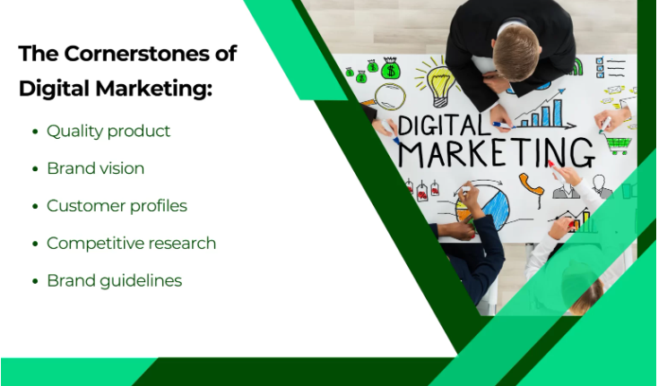

Brand Guidelines
Since digital marketing is one of the ways to build an interaction with the outside world, brand guidelines are critical in maintaining this relationship.
Brand guidelines mostly dictate how your brand must be marketed on social media platforms.

High-Quality Products
High quality of a brand products is a strong suit of any digital marketing strategy in Dubai.
It is not wrong to state that any digital marketing strategy is built on a strong product.
If you use all the available marketing strategies and techniques to reach out to the market but the product being sold does not meet the standards of the potential customers, the exercise will just be in vain.

Brand Vision
The vision of the specific brand is the key to the strategic direction of organizational marketing.
First and foremost, brand vision prevents implemented strategies from deviating and straying away from your business objectives.

Profiles Of Customers
It is imperative to understand customers' profiles very well enough.
The proper understanding of the customers’ characteristics makes it easier to use the appropriate marketing approaches for them.

Market Competitive Research:
Competitor analysis is very critical when it comes to gaining a better understanding of the market.
It is useful as it enables one to establish the strengths and weaknesses of the brand besides helping it to discover the prospects as well as threats.
Better Response Rate:
Digital marketing strategies can be easily changed from time to time depending on the responses and results received, thus making it easy to make changes.

9 Major Types of Digital Marketing:
Here are 9 major types of digital marketing that you will see in different forms. Let’s discuss each type one by one:
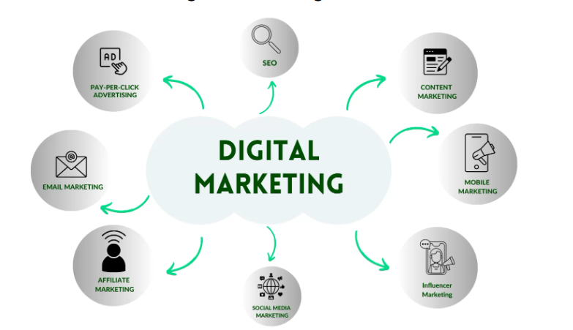

Search Engine Optimization (SEO):
SEO in Dubai plays a significant part in placing a brand at the top of SERF (Search Engine Results Page) when someone searches for related products and services that the brand offers.
Search engine optimization not only increases traffic by ensuring the positioning of the site rank for increased visibility to the users but also increases sales and conversion rates.
Example:
A digital marketing agency in Dubai will target keywords such as “Dubai digital marketing agency near me” to target the consumers who are in the process of searching for marketing services in the city.

Marketing Through Engaging Content:
Content marketing refers to a strategy that aims at developing and sharing content to generate value, relevance, and consistency that is appealing to the target audience. Moreover, if you want to increase credibility and trust or want to make your audience convert to clients who are willing to spend their money, then content marketing is the best option.
Example:
A digital marketing company in Dubai may write a blog that provides information on tips and trends in digital marketing services in Dubai.
This way, customers will get to know which services will suit well to their business objectives.

Mobile Marketing
Mobile marketing targets mobile users who also use mobile devices, including smartphones and tablets, among others.
It encompasses the use of short message service marketing, application-based marketing, and website-based marketing that is responsive to mobile.
Example:
A food delivery application used in Dubai reminds customers to use the application to get more offers or discounts available on the next order to encourage more orders.

Social Media Marketing:
Social media marketing is a type of marketing that relies on social media sites to reach the targeted audience and to advertise products or services.
Social media marketing in Dubai mostly relies on relevant strategies, such as the utilization of current trends and engaging content in a manner that will generate a response from the audience.
Example:
A digital marketing Dubai agency uses different social media platforms to share information about their brand products and services. This way, brands can share information, and for customer engagement, they respond to the comments and messages.

Influencer Marketing:
Influencer marketing is a marketing process that targets an influential person who has followers on various social platforms.
Through influencing marketing, brands can promote their products and services with ease in the most cost-effective way.
One of the major benefits of influencing marketing is that influencers can influence their audience's decision to make a purchase.

Example:
A cosmetic brand operating in Dubai can enlist beauty gurus on the Instagram platform to publicize its products.

Pay-Per-Click (PPC) Advertising:
Pay-per-click (PPC) is one of the Internet marketing models where the advertisers pay for each click received on the ads placed.
It is a process where traffic is gained through a paid process, which is totally opposite to SEO, where traffic is gained naturally.
Example:
Google AdWords, where a Digital Marketing Agency in Dubai can post its message on the search results page. Whenever a user enters related terms, then that post comes at the top of search results. Payment of the amount, in this case, depends on how many users click on the link.

Email Marketing:
Email Marketing basically entails covering a group of people with a particular type of message through the use of email. It is a marketing communication tool handy in building a relationship and converting customers.
Example:
An online marketing agency in Dubai can possibly use weekly newsletters to provide the members with recommended tips related to progress and trends.

Video Marketing:
Video marketing involves the use of video to market a product or a service. Video marketing is the perfect way to create an interaction with the target audience or increase the marketer's presence on social networks.
Example:
A hotel in Dubai has an opportunity to make a number of video tours to share various services and activities for tourists on their territory.

Affiliate Marketing:

Affiliate marketing is a type of marketing where an individual or a company profits from an agreement between different parties.
In this form of marketing, an affiliate gets paid whenever he brings traffic or customers to the merchant’s site.
Example:
Bloggers are also a powerful tool for the e-commerce store in Dubai that may comprise bloggers in promoting the store’s products.
They will receive a percentage depending on the sales made through their referral links.

Digital Marketing Challenges in the Present Context:
Apart from having so many advantages, as we discussed above, there are some challenges too that this platform has to face.
Such challenges may include cultural factors, technological issues, etc.

Cultural Sensitivity:
Dubai is a multicultural city.
At first, there is a dire need to understand cultural differences and the working culture of the Dubai market.
It can be clearly understood that a particular campaign that is effective in one country may not function effectively in another.
It is very important to understand the culture of the local people to succeed.

Technological Barriers:
There are several challenges that are still present in Dubai, though the emirate is considered to be technologically developed.
Such challenges are related to internet speed, the usage of mobile devices, and adequate digital facilities differ.
Consequently, businesses have to align their functioning in a better way to cope up with such challenges in an effective way.

Constantly Changing Trends:
Marketing has always been dynamic over many years, especially in the modern technological era.
New platforms, tools, and strategies are created quite often now.
It is important to note such trends as the world undergoes these changes if you want to exceed in the dynamic market of Dubai.

Emerging Platforms:
There are always new opportunities to appear in the form of new sites and interesting digital channels.
To maintain competitiveness in the international markets and region, the business people in Dubai should ensure that they keep abreast with these opportunities.
For instance, TikTok has become a new entertainment source and has new strategies for targeting consumers.

Evolving Consumer Behavior
Consumer behavior is not static.
New trends are constantly emerging regarding people’s daily usage of the Internet. That’s why it is crucial for Dubai brands to shift gears according to consumer demands.
Realizing such changes is important if you have to develop the right digital marketing strategies to achieve better results.

High Global Competition
The dynamics of Dubai's digital marketing are constantly changing due to the highly competitive environment.
Companies in the global market compete for the attention of the buyers. That’s why it is essential for the local business to be strategic and think of the way forward.

B2B vs. B2C Digital Marketing:
Let’s discuss some points that differentiate B2B digital marketing from B2C digital marketing:

B2B (Business-to-Business):
B2B is an acronym for business to business, and it refers to a form of digital marketing where the targeted are other businesses.
The idea behind B2B marketing is to get in contact with people who may require whatever you are selling or offering.
Most B2B advertising contains more information and has a longer period of the purchasing cycle.
Its purpose is to increase credibility and showcase one’s knowledge and experience.
Moreover, the use of digital marketing in business-to-business marketing is critical in Dubai, specifically in the real estate, finance, and technology industries.
These sectors need a special approach to their decision-makers, and that is why a great number of job offers can be found there.

B2C (Business-to-Consumer):

B2C digital marketing targets individual consumers.
The goal is to inform and immediately lead the target consumers to purchase the recommended products.
In the case of B2C, the strategies that are most commonly used are based on the creation of an emotional involvement and immediate call to purchase.
Concisely, Due to its status as a tourist destination, Dubai has a very large B2C market.
Local firms and Stores here employ promotional tools in business and advertising to entice visitors as well as residents with relevant B2C strategies.

The Impact of Digital Automation on Digital Marketing:
Automation is transforming digital marketing in every aspect.
It helps to make it easier for businesses to improve their performance of the business.
Apart from benefits, automation also creates new problems that do not exist in the conventional environment of formal organizations.

Benefits of Automation:
Marketing is an area suitable for automation, for instance, sending newsletters and social media updates.
This frees up time for more strategic activities.
Moreover, it helps to maintain consistency and avoid the creation of confusing messages that compromise the effectiveness of the campaign.

Challenges of Automation:
On the other hand, the role of automation is priceless, but it should be utilized suitably. Business needs to make a conscious effort to ensure the automation activities fit into the organization’s strategic plan.
That’s why it is very important to use personalization even in an attempt at an automated campaign.

How to Measure Digital Marketing Campaign Success?
Digital Marketing campaign success does not depend on the number of likes, followers, or fans that one possesses on social media sites.
It comprises the identification of how effectively several campaigns correspond to their organizational objectives.
There are different indicators to evaluate the effectiveness of a project.

Key Performance Indicators (KPIs):
Performance indicators that measure the achievement of change management initiatives are key in determining whether or not those changes are effective.
Some of the most often used KPIs are web metrics such as traffic, conversion rates, and engagement.
Such KPIs are crucial since they help in determining the impact of the internet and social media advertising campaigns.

Qualitative Measures:
The qualitative measures should also be evaluated to analyze the performance.
Customer opinions, attitude towards the brand, and level of satisfaction are important aspects of its performance.
They give a broader perspective of the results of a campaign in the market.

Proper Analysis of Digital Marketing Costs and Budgeting
It is of utmost importance to have an understanding of how much you are willing to spend on your digital marketing campaign.
As with any strategy, costs can be quite diverse based on the measures implemented to reach the goal.
That is why understanding the indicated costs is crucial to making the most rational decisions on the distribution of funds.

Key Cost Factors:
There are some parameters that define the cost of online marketing.
Such as the platforms that are normally employed in the campaigns, the nature of the campaigns run, and the number of attempts to reach the target audiences.
This is an implication that in the allocation of budgets, the following factors have to be taken into consideration by organizations that want to attain the maximum out of their campaigns.

Effective Budget Allocation:
It entails the act of focusing on activities that will provide the highest value in terms of return on investment.
It is also important for businesses to have petty cash to fund the tests for products and services as well as create new ideas.

Final Thoughts:
Digital marketing as a concept in Dubai has become very significant and widely accepted due to its efficacy and constant growth.
No matter if you are running a small business or mega brand, familiarising yourself with the landscape is something that is very important.
Three Angle Marketing is a digital marketing agency that provides targeted services for various startups and businesses operating in Dubai.
Our knowledge of both business-to-business and business-to-consumer marketing strategies, as well as local and international tendencies, guarantees that the campaigns are successful.
Call us now and see how you can benefit from our services to boost your business in Dubai’s fast-growing digital economy.

